**The PROMPT Framework Cheat Sheet: Your Guide to Powerful AI Prompts**

Get Exactly What You Want from ChatGPT, Copilot, and More

**1. The PROMPT Framework**

**What it is:** A simple, six-part framework to help you craft clear and effective prompts for Generative AI tools.

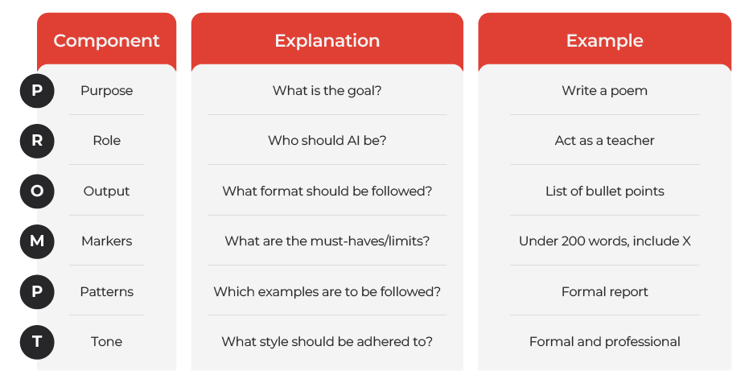

**Breakdown of Each Element**

● **P - Purpose:** What do you want the AI to do?

○ *Write, summarize, translate, brainstorm, etc.*

○ ***Example:*** *Write a short story, Generate marketing slogans, and Summarize*

*this article.*

● **R - Role:** What persona should the AI adopt?

○

○

*Expert, friend, critic, comedian, etc.)*

***Example:*** *Act as a travel agent, Pretend you're a chef, and Be a helpful*

*tutor.*

● **O - Output:** What format should the response be in?

○

○

*List, paragraph, poem, code, email, etc.*

***Example****: Give me a bulleted list, Write a short paragraph, and Create a*

*table.*

● **M - Markers:** What are the constraints or must-haves?

○ *Length, keywords, specific inclusions/exclusions*

○ *Example: Keep it under 100 words, include the phrase "artificial*

*intelligence," and avoid jargon.*

● **P - Patterns:** What template or examples should be followed?

○ *Formal Report, Cover letter, etc.*

○ *Example: Use a formal report template, use a cover letter template, and*

*write in the style of Shakespeare.*

● **T - Tone:** What style should the AI use? *(Formal, informal, humorous, serious,*

*enthusiastic, etc.)*

○ *Example: Be enthusiastic and encouraging, Use a formal and professional*

*tone, and Be sarcastic.*

**2. Prompting Tips & Best Practices**

● **Start Simple:** Begin with 2-3 PROMPT elements (**Purpose is essential**) and add

more as needed.

● **Be Specific:** The more precise your prompt, the better the result. Avoid vague

language.

● **Iterate:** Don't be afraid to refine your prompt if the initial output isn't what you

want.

● **Experiment:** Try different combinations of PROMPT elements to see what works

best.

● **Review and Edit:** Always review and edit AI-generated content. AI is a tool, not a

replacement for your judgment.

● **Context is Key:** Provide enough background information for the AI to

understand your request.

● **Use Clear Instructions:** State what you are after.

**3. Example Prompts (Using the Framework)**

***●* Travel Itinerary**

○

**Prompt:** "Create a 3-day travel itinerary for Paris. Act as an experienced

travel agent. Provide a day-by-day plan with activities and restaurant suggestions. The budget is mid-range, and the focus is on art museums and iconic landmarks. Use an enthusiastic and informative tone."

○ **(P)** Create Itinerary **(R)** Travel Agent **(O)** Day-by-Day plan **(M)** 3-day,

Paris, Budget, Art and Landmarks **(P)** Day-by-day Format **(T)** Enthusiastic   
***●* Email Draft**

○ **Prompt:** "Write a formal email to a client apologizing for a delay in

service. The tone should be professional and empathetic."

○ **(P)** Write Email **(O)** Formal Email **(T)** Professional, Empathetic

***●* Article Summary**

○ **Prompt:** "Summarize this news article about artificial intelligence in

three bullet points. Focus on the main benefits and challenges."

○ **(P)** Summarize article **(O)** Three Bullet Points **(M)** Benefits and

challenges

***●* Explaining a Concept**

○ **Prompt:** "Explain blockchain technology as if you are talking to a 10-year-old. Act as a friendly explainer. The tone should be simple and clear."

○ **(P)** Explain Blockchain **(R)** Friendly Explainer **(T)** Simple, Clear

**4. Prompt Starters**

● Act as a ...

● Create a ...

● Please provide ...

● I need help drafting ...   
● Write a...

● To summarize...

● Explain...

3

**5. Prompt Builder - Create Your Own!**

|  |  |  |
| --- | --- | --- |
| **Element** | **Description** | **Your Input** |
| **P (Purpose)** | What do you want the AI to do? |  |
| **R (Role)** | What persona should the AI adopt? |  |
| **O (Output)** | What format should the response be in? |  |
| **M (Markers)** | What are the constraints/must-haves? |  |
| **P (Patterns)** | What are the templates/examples? |  |
| **T (Tone)** | What style should the AI use? |  |

**My Complete Prompt:**

**Notes Section**